**Practical Assignment**

**Python Code:**

1. PIR sensor to detect motion and light the bulb.

Code:

int releNO = 13;

int inputPir = 2;

int val = 0;

int resuldoSensorLDR;

int sensorLDR = A0;

void setup()

{

pinMode(releNO, OUTPUT);

pinMode(inputPir, INPUT);

pinMode(sensorLDR, INPUT);

Serial.begin(9600);

}

void loop()

{

val = digitalRead(inputPir);

resuldoSensorLDR = analogRead(sensorLDR);

if(resuldoSensorLDR<600)

{

if(val == HIGH)

{

digitalWrite(releNO, HIGH);

delay(5000);

}

else{

digitalWrite(releNO, LOW);

delay(300);

}

}

else{ digitalWrite (releNO, LOW);

Serial.println(resuldoSensorLDR);

delay(500);

}

}

Circuit diagram:

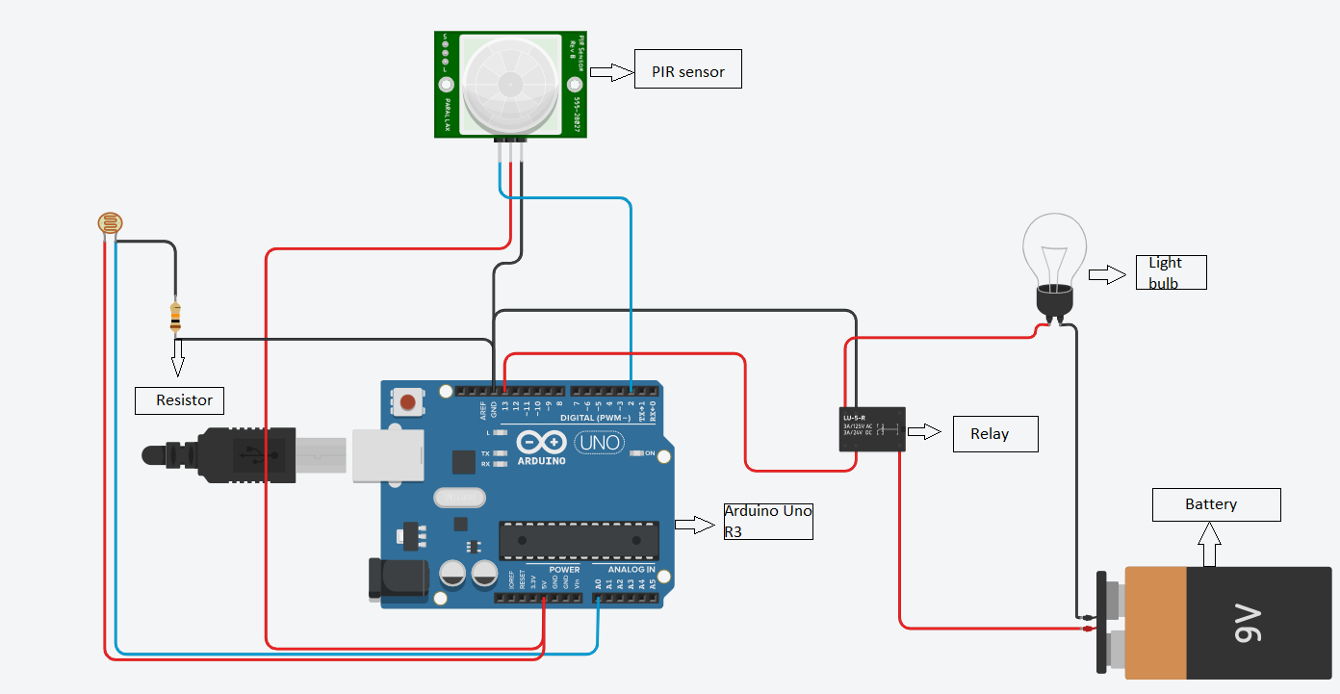

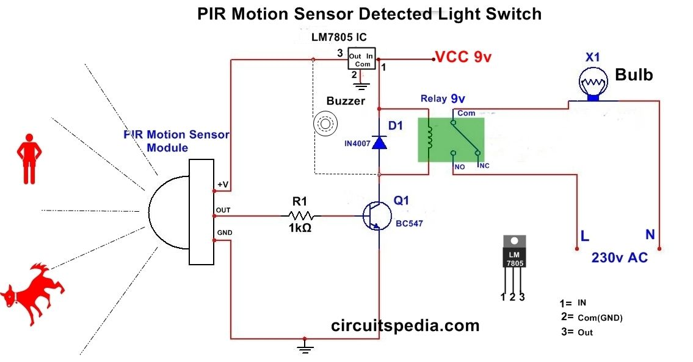

1. Water Level Detector.

Code:

void setup()

{

pinMode(13, OUTPUT);

}

void loop()

{

digitalWrite(13, HIGH);

delay(1000); // Wait for 1000 millisecond(s)

digitalWrite(13, LOW);

delay(1000); // Wait for 1000 millisecond(s)

}

Output:

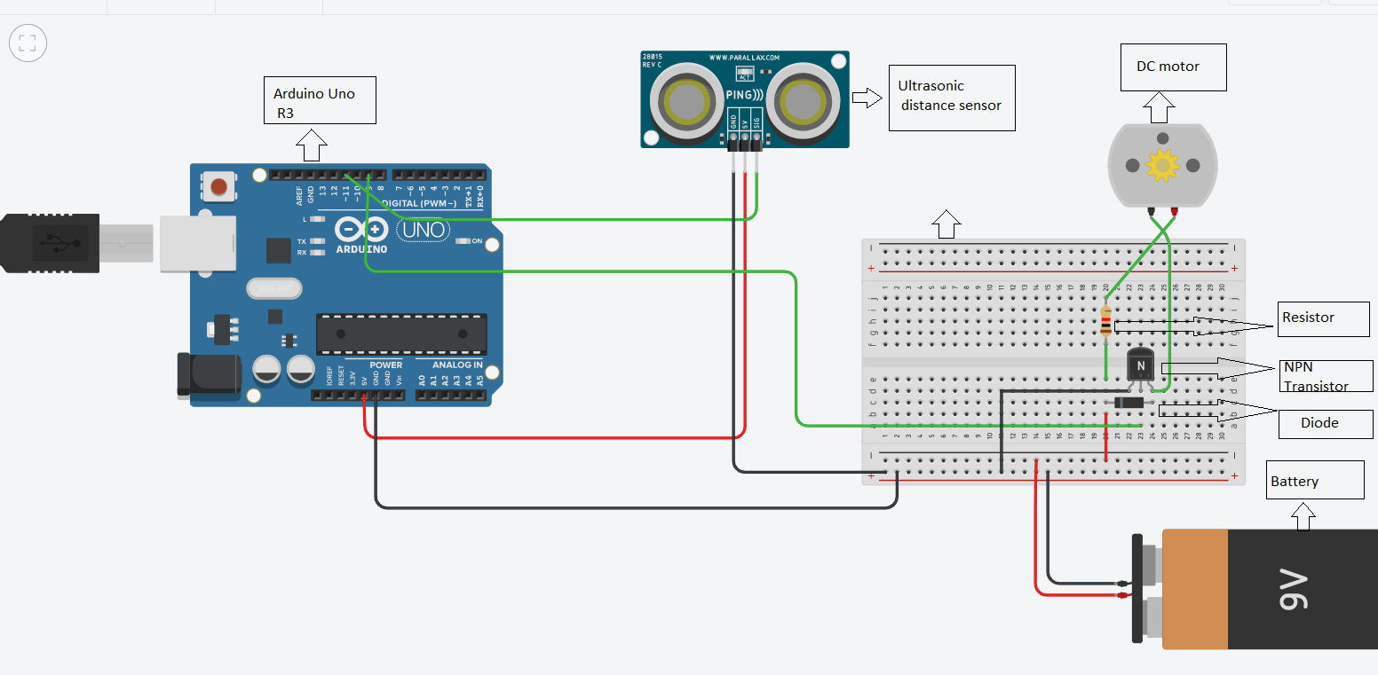

1. Smoke sensor with buzzer alarm.

Code:

const int gasPin = A0;

void setup()

{

Serial.begin(9600);

}

void loop()

{

Serial.println(analogRead(gasPin));

delay(1000);

}

Output:

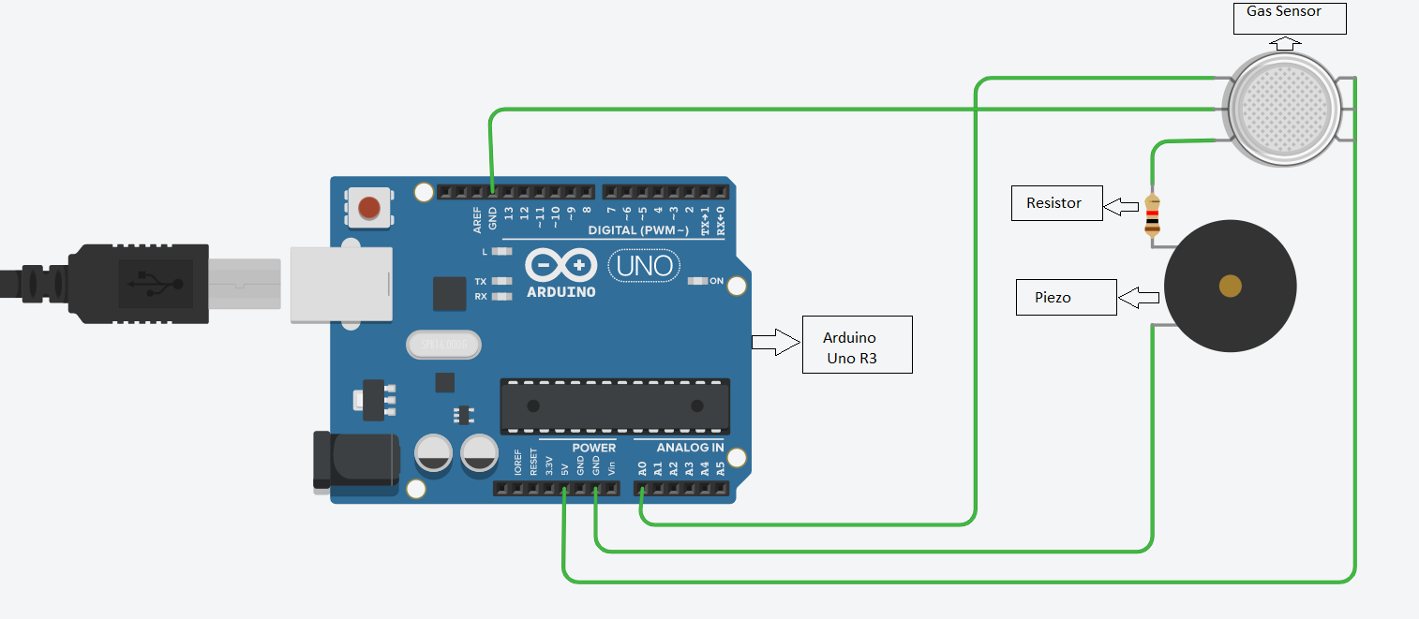

1. Room having 2 light bulb and 2 fan.

Code:

void setup()

{

pinMode(13, OUTPUT);

}

void loop()

{

digitalWrite(13, HIGH);

delay(1000); // Wait for 1000 millisecond(s)

}

Output:

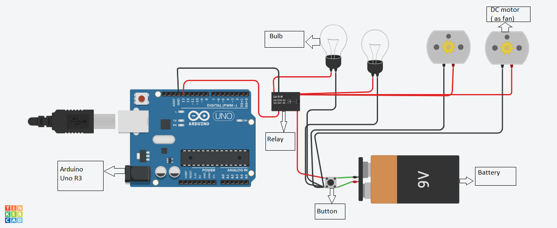

**ANDROID CODE**

**Now we are going to make application in android studio:**

**Xml code:**

*<?***xml version="1.0" encoding="utf-8"***?>*<**LinearLayout xmlns:android="http://schemas.android.com/apk/res/android"  
 xmlns:app="http://schemas.android.com/apk/res-auto"  
 xmlns:tools="http://schemas.android.com/tools"  
 android:layout_width="match_parent"  
 android:layout_height="match_parent"  
 tools:context=".MainActivity"  
 android:orientation="vertical"**>  
  
  
 <**Switch  
 android:id="@+id/RL1"  
 android:layout_width="match_parent"  
 android:layout_height="wrap_content"  
 android:text="RL1"** />  
 <**Switch  
 android:id="@+id/RL2"  
 android:layout_width="match_parent"  
 android:layout_height="wrap_content"  
 android:text="RL2"** />  
 <**Switch  
 android:id="@+id/RL3"  
 android:layout_width="match_parent"  
 android:layout_height="wrap_content"  
 android:text="RL3"** />  
 <**Switch  
 android:id="@+id/RL4"  
 android:layout_width="match_parent"  
 android:layout_height="wrap_content"  
 android:text="RL4"** />  
  
 <**TextView  
 android:layout_width="match_parent"  
 android:layout_height="100dp"  
 android:text="rajeev singh 18mca8142"** />  
</**LinearLayout**>

**Mainactivity.java**

**package** com.example.cu_iot_assignment;  
  
**import** androidx.appcompat.app.AppCompatActivity;  
  
**import** android.os.Bundle;  
**import** android.view.View;  
**import** android.widget.Switch;  
  
**import** com.google.firebase.database.DatabaseReference;  
**import** com.google.firebase.database.FirebaseDatabase;  
  
**public class** MainActivity **extends** AppCompatActivity {  
 Switch **rl1**,**rl2**,**rl3**,**rl4**;  
  
 **private** FirebaseDatabase **database**;  
 **private** DatabaseReference **databaseReference**;  
 @Override  
 **protected void** onCreate(Bundle savedInstanceState) {  
 **super**.onCreate(savedInstanceState);  
 setContentView(R.layout.***activity_main***);  
 **rl1**=findViewById(R.id.***RL1***);  
 **rl2**=findViewById(R.id.***RL2***);  
 **rl3**=findViewById(R.id.***RL3***);  
 **rl4**=findViewById(R.id.***RL4***);  
 **rl1**.setOnClickListener(**new** View.OnClickListener() {  
 @Override  
 **public void** onClick(View v) {  
 **database** = FirebaseDatabase.*getInstance*();  
 **databaseReference** = **database**.getReference(**"dh11"**);  
 **if**(**rl1**.isChecked()) {  
  
 **databaseReference**.child(**"RL1"**).setValue(1);  
 }  
 **else** {  
 **databaseReference**.child(**"RL1"**).setValue(0);  
 }  
  
 }  
 });  
 **rl2**.setOnClickListener(**new** View.OnClickListener() {  
 @Override  
 **public void** onClick(View v) {  
 **database** = FirebaseDatabase.*getInstance*();  
 **databaseReference** = **database**.getReference(**"dh11"**);  
 **if**(**rl1**.isChecked()) {  
  
 **databaseReference**.child(**"RL2"**).setValue(1);  
 }  
 **else** {  
 **databaseReference**.child(**"RL2"**).setValue(0);  
 }  
  
 }  
 });  
 **rl3**.setOnClickListener(**new** View.OnClickListener() {  
 @Override  
 **public void** onClick(View v) {  
 **database** = FirebaseDatabase.*getInstance*();  
 **databaseReference** = **database**.getReference(**"dh11"**);  
 **if**(**rl1**.isChecked()) {  
  
 **databaseReference**.child(**"RL3"**).setValue(1);  
 }  
 **else** {  
 **databaseReference**.child(**"RL3"**).setValue(0);  
 }  
  
 }  
 });  
 **rl4**.setOnClickListener(**new** View.OnClickListener() {  
 @Override  
 **public void** onClick(View v) {  
 **database** = FirebaseDatabase.*getInstance*();  
 **databaseReference** = **database**.getReference(**"dh11"**);  
 **if**(**rl1**.isChecked()) {  
  
 **databaseReference**.child(**"RL4"**).setValue(1);  
 }  
 **else** {  
 **databaseReference**.child(**"RL4"**).setValue(0);  
 }  
  
 }  
 });  
 }  
}

**OutPUT:**

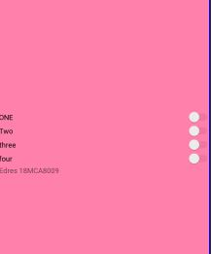

Github link: <https://github.com/MohammadEdresGhafoori/IOT_Assignment>